NAME: Shriya Ramya Mohan Exp : 10
ROLL No.:241901106

CUSTOMIZE SWITCH WITH NETWORK MODULES USING CISCO PACKET TRACER

AIM:
To customise Switch with Network Modules using Cisco Packet Tracer.
ALGORITHM:
- Open Cisco Packet Tracer and place a switch in the workspace.
- Click the switch to open its device window and go to the Physical tab.
- Power off the switch by clicking the red power button.
- Select a desired network module from the module list.
- Drag and insert the module into an available slot on the switch chassis.
- Power on the switch by clicking the power button again.
- Verify the new module and interfaces are recognised in the Config or CLI tab.

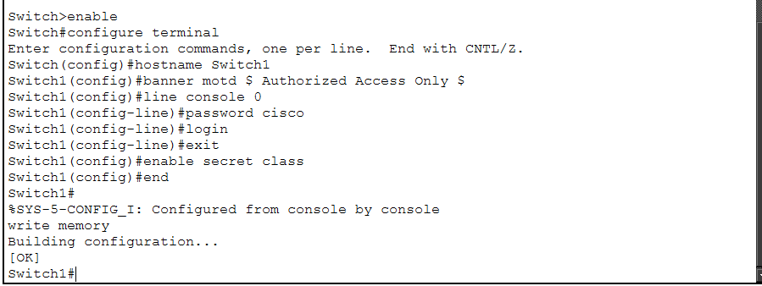
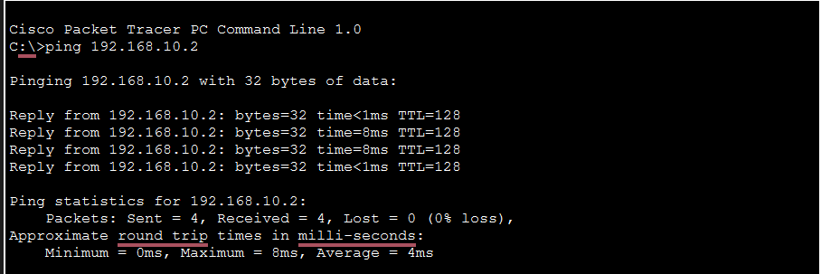

RESULT:
The switch was successfully customised with additional network modules in Cisco Packet Tracer.

